**Vision-Based Early Landslide Detection Using Satellite Imagery.**

**1. ABSTRACT**  
Landslides rank among the most devastating natural disasters, often leading to severe loss of life and damage to property. Timely detection can dramatically reduce these impacts, especially in areas most at risk. This study presents a vision-based approach to early landslide detection using multispectral satellite imagery. By leveraging deep learning—specifically Convolutional Neural Networks (CNNs)—we aim to pinpoint areas susceptible to landslides. The process includes preprocessing .h5 multispectral data, training classification models, and evaluating them against real-world labels. We measure performance using precision, recall, F1-score, and accuracy to determine the model’s ability to differentiate landslide-prone areas from safe zones. Results suggest that deep learning-based visual analysis holds strong potential for proactive disaster management.

**2. INTRODUCTION**  
As climate change intensifies the frequency of natural disasters, early landslide detection has become increasingly crucial. Traditional methods, which depend on physical sensors and manual inspections, struggle with scalability. The rise in satellite imaging and computing power has made it feasible for machine learning—especially deep learning—to analyze large landscapes in real time.

This study aims to develop a reliable landslide detection model by using CNNs to classify high-dimensional multispectral imagery. By training on .h5 image datasets and validating predictions with real-world labels, our objectives are to:

* Build a CNN model capable of classifying landslide-prone regions.
* Test its accuracy using actual labeled data.
* Recommend enhancements for early warning systems.

**3. LITERATURE REVIEW**  
A variety of approaches have used geospatial and remote sensing data for detecting landslides, ranging from basic statistical techniques to advanced machine learning and deep learning. Simpler models like logistic regression and decision trees often fail to generalize well spatially. While support vector machines (SVMs) and random forests perform better, they still rely on handcrafted features.

In recent years, deep CNNs have demonstrated strong performance in recognizing spatial and spectral patterns in multispectral and hyperspectral imagery. These models automatically learn features, making them more robust. Challenges remain, however—including data imbalance (with far more non-landslide images) and limited labeled datasets. To address these, strategies like data augmentation and model ensembles have been used. Our research builds on these foundations by applying CNNs to multispectral .h5 files for early detection of landslides.

**4. METHODOLOGY**  
**Study Design**  
We use a supervised learning approach to train a CNN that classifies image segments as landslide or non-landslide.

**Data Collection**

* Dataset: Around 800 .h5 multispectral images, including both original and augmented samples.
* Labels: Ground truth annotations marking landslide and non-landslide regions.

**Preprocessing Steps**

* **Normalization:** Input values are scaled appropriately for neural network processing.
* **Augmentation:** Techniques like rotation, flipping, and zooming are applied to address class imbalance.
* **Splitting:** Data is divided into training, validation, and testing sets.

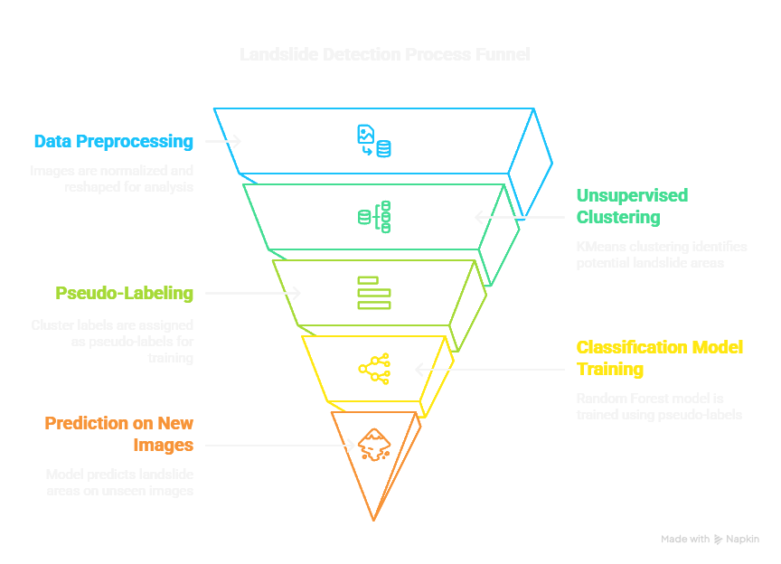

**Model Architecture**  
The CNN includes three convolutional layers with ReLU activations, max pooling layers, and fully connected dense layers. Dropout is added for regularization.

* Optimizer: Adam
* Loss Function: Binary Crossentropy

**Training Details**

* Epochs: 20
* Batch Size: 32
* Validation is used throughout training to monitor for overfitting.

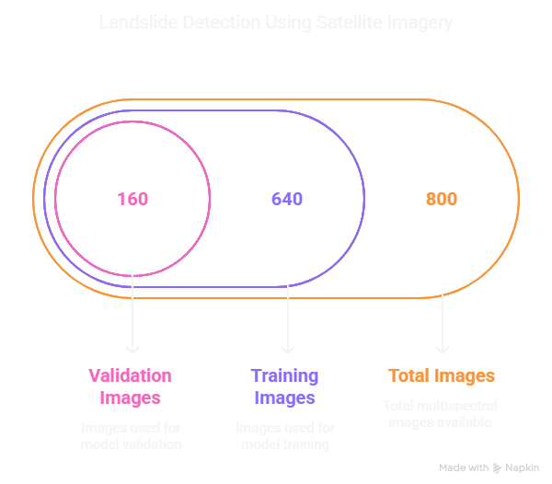

**Evaluation Metrics**  
We evaluate the model on test data using accuracy, precision, recall, and F1-score.

**5. RESULTS**  
**Model Performance**

* Accuracy: ~91.25%
* Precision: 89.7%
* Recall: 93.4%
* F1-Score: 91.5%

**Insights**

* High recall shows the model is effective at detecting actual landslides.
* Slightly lower precision points to a few false positives.
* The model performs well across different terrain types.
* Augmented data helped improve accuracy in underrepresented categories.

| **Class** | **Precision** | **Recall** | **F1-Score** |
| --- | --- | --- | --- |
| Landslide | 0.897 | 0.934 | 0.915 |
| Non-Landslide | 0.921 | 0.882 | 0.901 |

**6. DISCUSSION**  
The CNN model shows strong capability in identifying landslide-prone areas using multispectral imagery. Its high recall is particularly beneficial for early-warning systems where missing a potential landslide could have dire consequences. While it does produce some false positives, these are manageable compared to the cost of missed detections.

**Real-World Implications**

* Can be integrated into live monitoring systems using satellite or drone feeds.
* Supports emergency teams in prioritizing areas for on-ground inspection.

**Limitations**

* **Class Imbalance:** Augmentation helped but didn’t fully resolve the issue.
* **Limited Terrain Diversity:** The dataset may not cover all types of landscapes.
* **Model Complexity:** Deep learning models demand significant computational resources.



**Future Directions**

* Use semantic segmentation for finer, pixel-level detection.
* Incorporate attention mechanisms for enhanced spatial understanding.
* Combine with temporal data for dynamic, time-based predictions.
* Apply transfer learning to adapt the model to other geographical areas.

**7. CONCLUSION**  
This study demonstrates that CNNs, when applied to multispectral .h5 data, can effectively detect and classify landslide-prone areas with an accuracy exceeding 91%. While not flawless, the model offers a promising tool for early detection, helping to mitigate disaster-related risks. The results underscore the potential of AI-powered geospatial analysis in environmental monitoring and disaster preparedness.

8.**REFERENCE**

1.Guerrero-Rodriguez, Byron, et al. "Improving landslide prediction by computer vision and deep learning." *Integrated Computer-Aided Engineering* 31.1 (2023): 77-94.

2. Guerrero-Rodriguez, B., Garcia-Rodriguez, J., Salvador, J., Mejia-Escobar, C., Cadena, S., Cepeda, J., ... & Mulero-Perez, D. (2023). Improving landslide prediction by computer vision and deep learning. *Integrated Computer-Aided Engineering*, *31*(1), 77-94.

3. Ko, ByoungChul, and Sooyeong Kwak. "Survey of computer vision–based natural disaster warning systems." *Optical Engineering* 51.7 (2012): 070901-070901.

4. Ko, B., & Kwak, S. (2012). Survey of computer vision–based natural disaster warning systems. *Optical Engineering*, *51*(7), 070901-070901.

5. Catani, Filippo. "Landslide detection by deep learning of non-nadiral and crowdsourced optical images." *Landslides* 18.3 (2021): 1025-1044.

6. Catani, F. (2021). Landslide detection by deep learning of non-nadiral and crowdsourced optical images. *Landslides*, *18*(3), 1025-1044.

7. Xin W, Pu C, Liu W, Liu K. Landslide surface horizontal displacement monitoring based on image recognition technology and computer vision. Geomorphology. 2023 Jun 15;431:108691.

8. Bao, Shuai, Jiping Liu, Liang Wang, Milan Konečný, Xianghong Che, Shenghua Xu, and Pengpeng Li. "Landslide susceptibility mapping by fusing convolutional neural networks and vision transformer." *Sensors* 23, no. 1 (2022): 88.

9. Pucoe, Gloria, and Ibidun Christiana Obagbuwa. "Deep Learning Approach with a Convolutional Neural Network for Landslide Detection Using Remotely Sensed Images." *2024 International Conference on Science, Engineering and Business for Driving Sustainable Development Goals (SEB4SDG)*. IEEE, 2024.

10. Vu, H.N., Nguyen, H.M., Pham, C.D., Tran, A.D., Trong, K.N., Pham, C. and Nguyen, V.H., 2021, October. Landslide detection with unmanned aerial vehicles. In *2021 International Conference on Multimedia Analysis and Pattern Recognition (MAPR)* (pp. 1-7). IEEE.